My Website Project

A Website can be constructed in various ways. To construct a website, we use a language called HTML. HTML allows us to create text which is loaded on to a page from top to bottom using tags which define each element in the code.
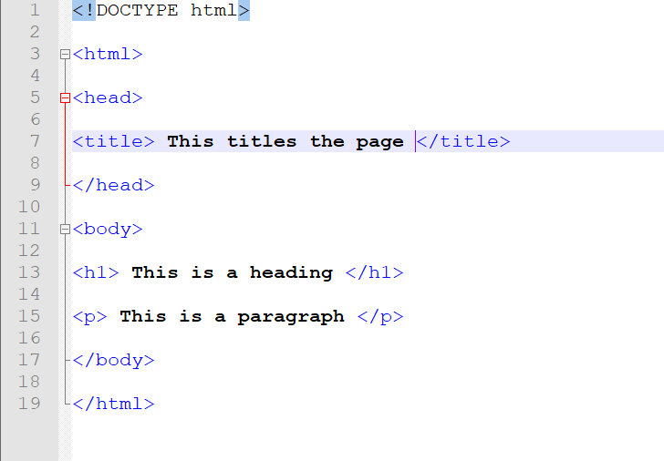
This is very basic html code which will display a heading and a paragraph.
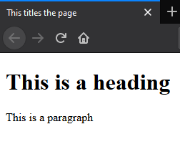
This is what will appear when you launch the code, showing basic black and white colours. The code shown above is the foundation of any website and whatever you add from there is the building blocks on top. From here we can change the text and start building a website about a topic we would be interested in. For this example, we will be using CinemaScope.
CinemaScope is a small independent company which has 5 cinemas across country which shows a variety of films. On top of this they run festivals of older films from time to time. This company will be transitioning from a newspaper advertisement process to a website advertisement.

